MODEL QUESTION PAPER

B.E. PRODUCTION ENGINEERING
V SEMESTER

PR 336 WELDING TECHNOLOGY

Time: 3hours Max. Marks: 100
Answer ALL Questions

PART – A (10 X 2 = 20Marks)

DISTINGUISH BETWEEN
- Oxidising and reducing flame
- Straight and reversed polarity
- Down hand and overhead position of welding
- Under cut and spatter

STATE TRUE OR FALSE AND JUSTIFY
- The arc efficiency of the metal arc process is higher than that of tungsten arc process.
- Cast iron is welded using matching electrodes
- Size and shape of the volume defects can be identified using eddy current testing.

DEFINE
- Arc blow
- Weld thermal cycle
- Seam tracking

PART – B (5 X 16 = 80 Marks)

Suggest suitable welding process for the following applications, justify your suggestion, describe the equipment, process, advantages and limitations of the process suggested. (2 x 8 = 16 Marks)

i) Welding of stainless steel plates of thickness 5mm. The plates are placed on the ground and the welding could be performed in multiple passes.

ii) Welding of High Speed Steel twist drill bits with carbon steel shanks.

12.a)i) Distinguish between Projection welding and Flash-butt welding (4)

ii) In a GTAW process, the arc voltage is 24 Volts, the arc current is 200 Amperes, voltage drop at cathode and anode are 9 and 5 volts respectively and 75% of the arc column energy is untransferred. The work function for Tungsten is 4.5eV and Boltzmann’s constant = 8.62 x 10⁻⁵ eV/K. Find out the arc efficiency. (8)

iii) Differentiate between rightward and leftward technique of welding (4)

(OR)

12.b)i) Compare and contrast between Metal Inert Gas and Metal Active Gas welding process in terms of equipment, shielding gas, applications, advantages and limitations. (8)

ii) What are the basic features of Submerged Arc Welding process? Describe the equipment, process, application and limitations of SAW process. (8)

13.a)i) Interpret the following symbols (2 x 4 = 8)

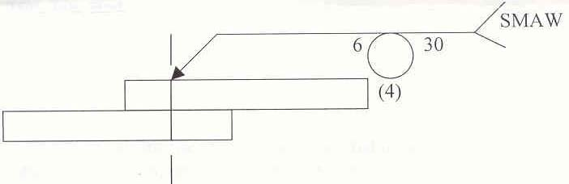

ii)
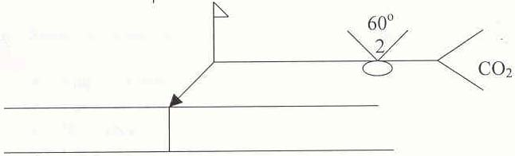

iii) What are the various positions of welding? List and explain them with suitable sketches. (8)

(OR)

13.b)i) Whether a single U or a double U groove is preferable for welding plates? Justify your suggestion. (4)

ii) What are the factors affect the selection of the pre heat temperature? and state a popularly used formula to find out the pre heat temperature. Find out the Preheat temperature necessary to weld a steel plate of thickness 8mm with a Carbon Equivalent of 0.6%. (6)

iii) What are the special features of Plasma Arc welding? Compare and contrast between un-transferred and transferred plasma arc process. (6)

14.a) State the working principle, construction of the equipment, process, effects of the process variables, applications and limitations of the following process

- Laser Beam Welding
- Ultrasonic Welding

(OR)

14.b)i) Classify the welding power source based on V–I characteristics. Explain the salient features and application of each type. (8)

ii) Define the term ‘Duty cycle’. Find out the maximum current that can be drawn at 100% duty cycle from a welding power source of current rating 400A at 75% duty cycle. (4)

iii) What is ‘self adjusting arc’? In what processes this kind of arc is preferable? and why? (4)

15.a)i) What are the various types of manipulators used in welding? Discuss their construction, operation and limitations. (8)

ii) State the causes and remedy for the following defects (8)

- Slag inclusion
- Lamellar tearing
- Hot crack
- Lack of penetration

(OR)

15.b)i) What is weld decay? How is this prevented? (6)

ii) Compare between the wedability of mild steel and high carbon steel (4)

iii) How are the onset of residual stress and distortion in welded structure prevented? (6)

-----

